Project 5: Render Your Scene With Primitives

Adonijah Farner and Dylan Johnson

Professor Citro

CST-310 Computer Graphics Lecture and Lab

October 20, 2024

Assigned Picture:

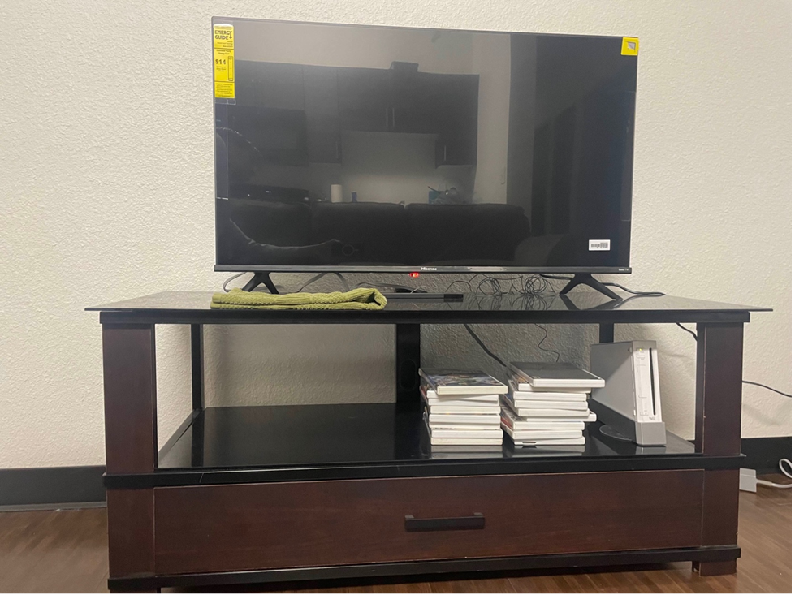

For the assigned picture, address the following:

1. List the objects in the foreground, background, and in-between.
   1. Foreground: TV Stand, Hand Towel, Stack of video games, Wii game console, TV, Wii sensor
   2. Background: Wall, floor, and floor trim
   3. In-between: Reflection on TV, reflection on TV stand top, reflection on TV stand base
2. Identify the main objects in the scene (e.g., buildings, trees, bridge).
   1. Main Objects: TV Stand, TV, Wall, TV reflections
3. Describe key characteristics of the scene (e.g., ambience).
   1. Cozy ambience with a calm/neutral color scheme and a casual setup.
4. Explain how you would approach rendering each object in the scene. For example: An elementary school would be represented by a set of cubes with trapezoidal rooftops. A tree would be represented by a cylinder with a reverse pyramid on top.
   1. TV Stand: Big flat rectangle for the base with four small rectangles on the bottom of each corner. Four long rectangles going upward from the top of each corner. A short flat rectangle on the top with the same width as the base rectangle.
   2. Hand Towel: Multiple cubes elongated and shaped to resemble a towel.
   3. Stack of video games: Multiple short rectangles stacked upon each other
   4. Wii console: A trapezoid for the base, a longer trapezoid on top of the base. Small rectangles for each button/detail, and an elongated rectangle for the cd disc slot.
   5. TV: A big flat rectangle for the screen on the tv, a smaller rectangle on the bottom of it for the edge of the tv, small rectangles on it for the stickers. Elongated pyramids at the bottom on each side for the stand.
   6. Wii sensor: Elongated rectangle.
   7. Wall: Giant rectangle.
   8. Floor Trim: Smaller rectangle on the bottom of the wall for the floor trim.
   9. Floor: Rotated Rectangle connected to the wall and below the TV stand.
   10. Objects in reflection: Multiple groups of rectangles for the collection of shelving, with lower color alpha values.
   11. Reflections on TV stand top: Rectangle given the texture of the wall and placed on top of the TV stand top on the left side. The opacity was scaled down to resemble the TV stand top and appear as a reflection.
   12. Reflections on TV stand base: Multiple rectangles with low opacity placed onto the base to give the impression of a reflection of the TV stand posts.
5. Rank all the objects in the scene in order of rendering difficulty.

**Most Difficult --> Easiest.**

* 1. Reflection on TV
  2. Towel
  3. TV Stand
  4. Wii Console
  5. TV
  6. Stack of games
  7. Wii Sensor
  8. Wall
  9. Floor
  10. Floor Trim
  11. TV stand top reflection
  12. TV stand base reflection

1. Draw a geometrical representation of the picture on paper, by hand, using pencil only.

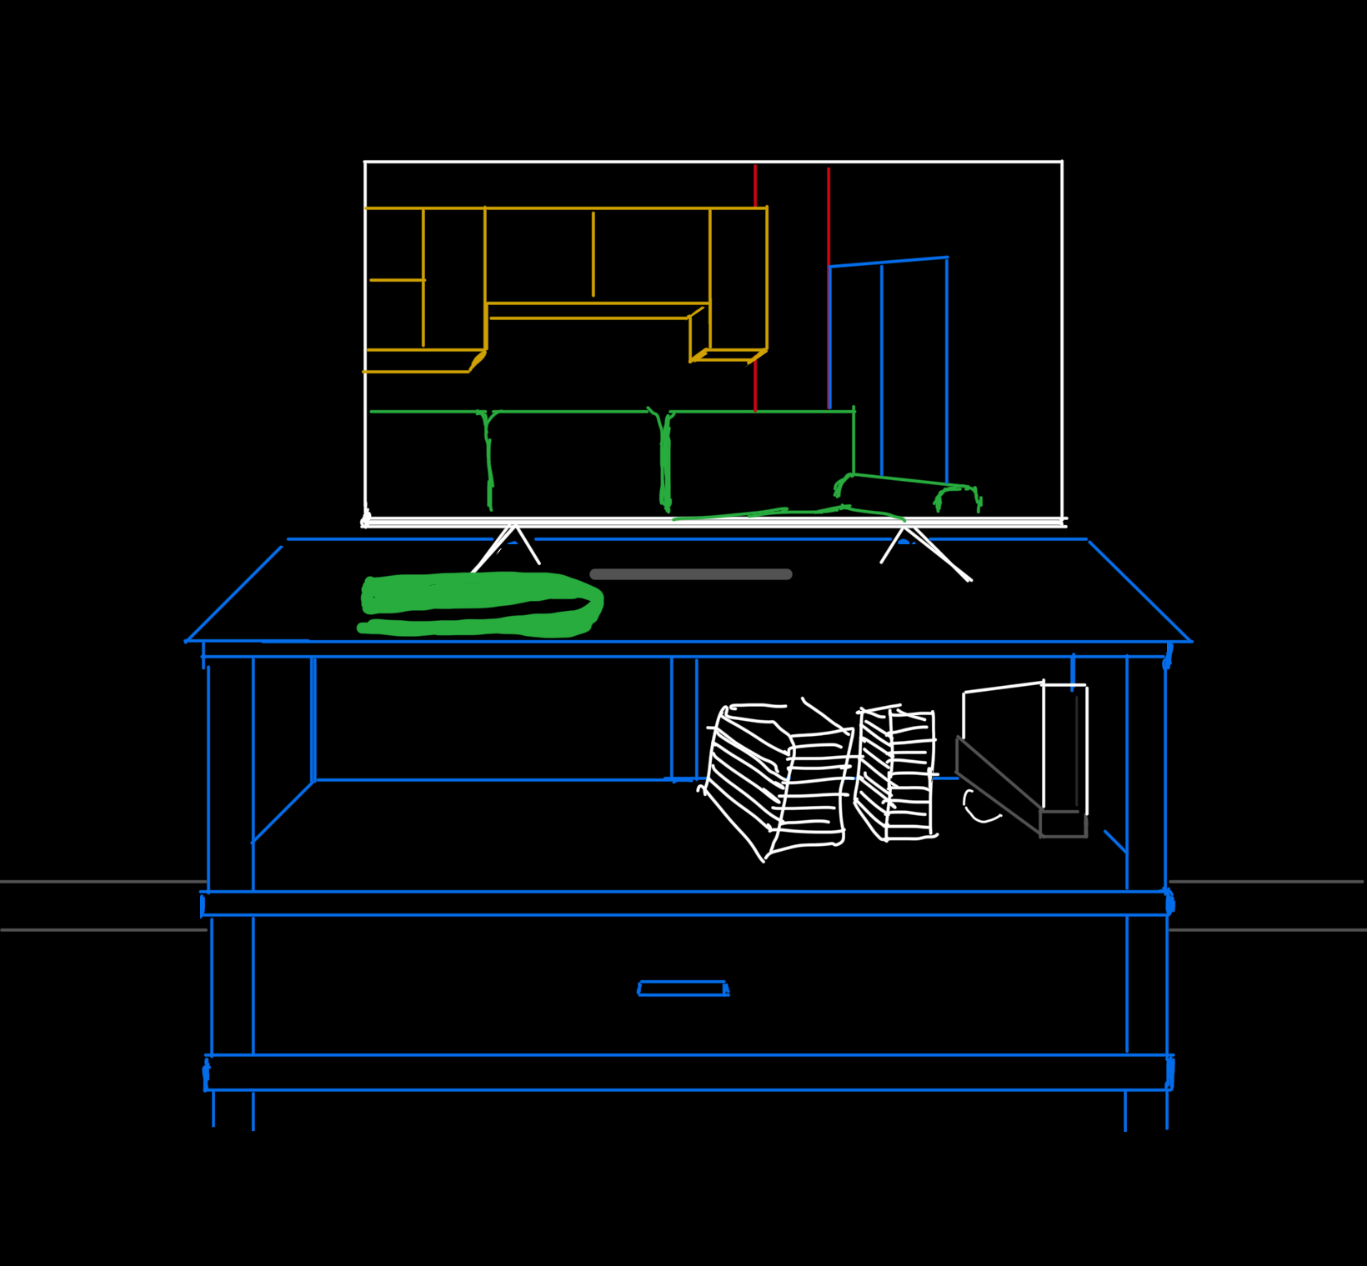

1. Scene rendered with primitives

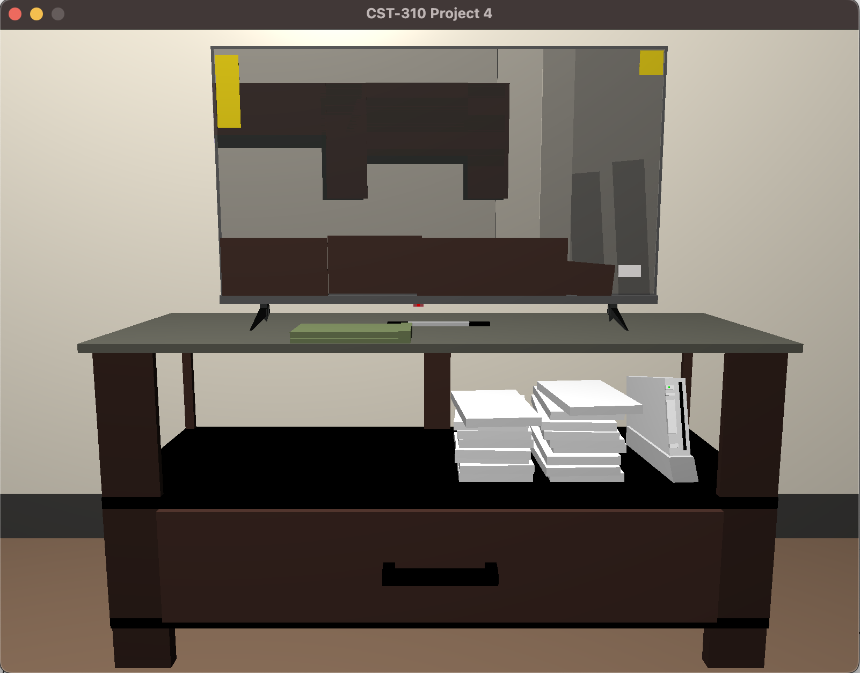

1. Scene rendered with more detailed primitives

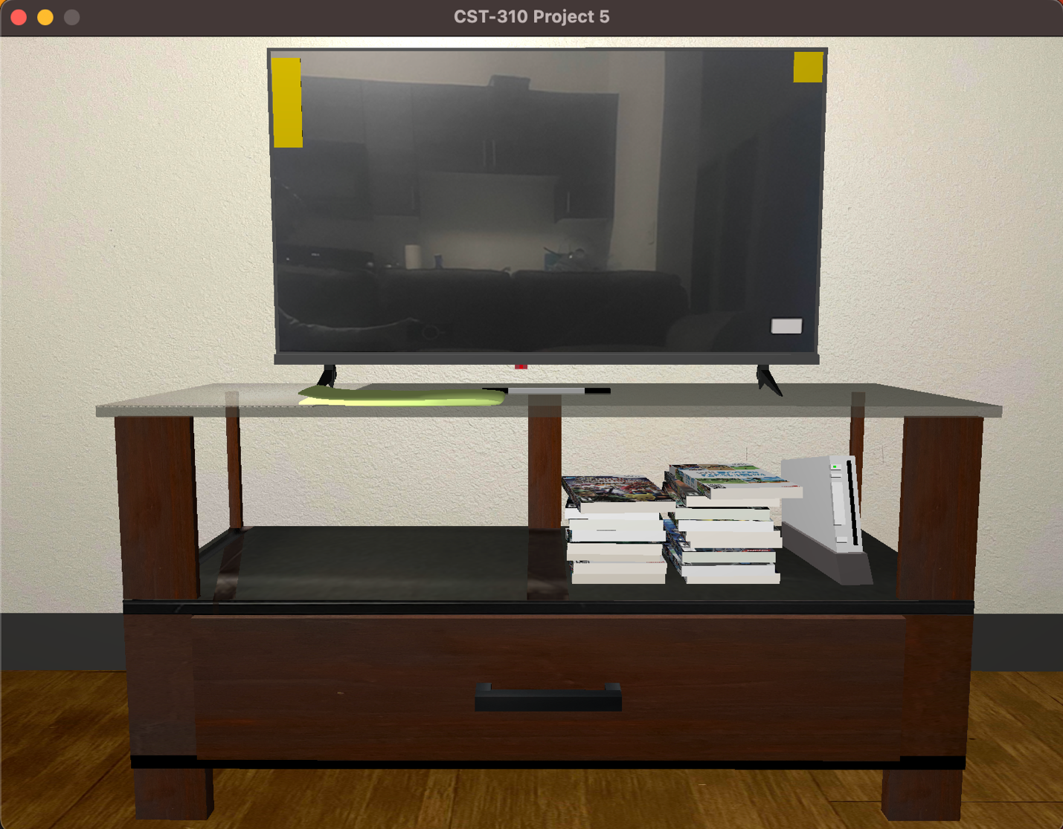

1. Show all four side by side.

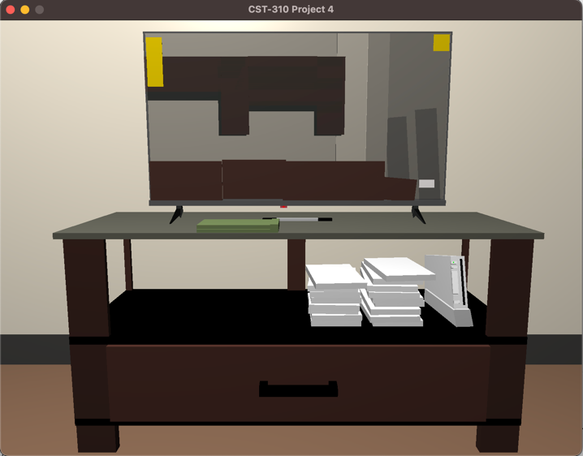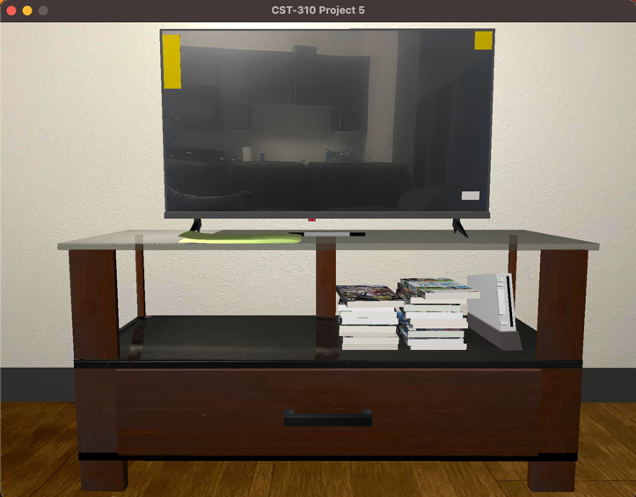

Project 5 Specifics:

1. Mathematical characteristics
   1. Reflection on TV: The reflections were modeled by placing a texture of the reflected image on top of the cube object in the Television object.
   2. Towel: The towel was modeled in blender, then imported into OpenGL and oriented onto the TV stand.
   3. TV Stand: The TV stand is placed at the origin and is the base for all other objects in the scene. It is comprised of scaled cubes with a multitude textures applied onto it to give the realistic effect.
   4. Wii Console: The console was placed upon the bottom shelf of the TV stand and was scaled downwards to make sense for the space, as well as being given extra cubes on top of it to add detailed buttons.
   5. TV: The television was placed atop the TV stand and scaled upward to match the scale of the image.
   6. Stack of games: The games were placed next to the wii and scaled to fit within the space and not overstretch. These rectangles were then given textures to place game images onto the face of each. Each rectangle was given a random set of three off-white colors to get a more realistic feeling.
   7. Wii Sensor: The sensor was placed between the television and the TV stand and is comprised of three cube structures.
   8. Wall: The wall was scaled up and placed behind the TV stand to give an appropriate backdrop for the scene. The wall was then given an appropriate texture.
   9. Floor: The floor was scaled up and rotated to be below the TV stand and the wall, and given an appropriate texture.
   10. Floor Trim: The floor trim was scaled and placed between the floor and the wall.
   11. Reflection on TV stand top: The reflection cube was scaled to lay on top of the TV stand top and mimic a reflection of the wall.
   12. Reflection on TV stand base: The reflection cubes were scaled and oriented to give the impression of a reflection of the TV stand posts onto the TV stand base.
2. The primitives used to render:
   1. Reflection on TV: A rectangle with a texture applied onto it.
   2. Towel: A blender object imported into the scene.
   3. TV Stand: A collection of elongated cubes placed in order to resemble the TV stand.
   4. Wii Console: Two trapezoids stacked on top of each other, with multiple rectangles placed on top of it to resemble the details of the console such as its buttons.
   5. TV: A combination of multiple rectangles stacked in/around each other to form the television and the stickers on it with a combination of pyramids and cubes placed below the television to model its stand.
   6. Stack of games: Multiple elongated cubes stacked upon each other.
   7. Wii Sensor: Elongated cubes placed next to each other to simulate the sensor bar.
   8. Wall: Elongated cube placed behind the TV stand.
   9. Floor: Elongated cube placed below the TV stand and wall
   10. Floor Trim: Elongated cube placed between the floor and wall.
   11. Reflections on TV stand top: Elongated cube placed on top of the TV stand top
   12. Reflections on TV stand base: Elongated cubes placed on top of the TV stand base and oriented to give the impression of a reflection.
3. All the transformations used and explanations on their use
   1. Reflection on TV: No rotations.
   2. Towel: The towels were not rotated.
   3. TV Stand: The TV stand was not rotated at all.
   4. Wii Console: The trapezoid used for the base was not rotated but the console and the cubes resembling its details were rotated.
   5. TV: The television was not rotated but the pyramids used for its stands were rotated to aim towards the TV stand.
   6. Stack of games: Each game was given a unique rotation based off of the original picture.
   7. Wii Sensor: The sensor was not rotated at all.
   8. Wall: The wall was not rotated.
   9. Floor: The floor was not rotated.
   10. Floor Trim: The trim was not rotated.
   11. Reflection on TV stand top: This object was not rotated.
   12. Reflection on TV stand base: The bigger cube in the center was not rotated. The smaller cube on the left was rotated 15 degrees on the y axis to give the impression that the reflection was going toward the camera.
4. The shader(s) used and explanations of the reasoning and what it/they accomplished

The shader used was given to us from professor Citro’s padlet marked as “Shader.h”, <https://padlet.com/ricardo_citro/introduction-to-computer-graphics-q3e8bhtb2qor>. This shader allowed us to set our scene with appropriate colors and lighting. Within our vertex and fragment shaders we used a base of the “basic_lighting.vs” and “basic_lighting.frag” files within the aforementioned padlet to add a sense of depth to our scene through lighting, and added use of the alpha value for a color, as in these base files changing the alpha value of a color did not change anything. When working with this alpha value, we discovered the importance in rendering order as things rendered after the transparent object will not be seen through it. We also added a Boolean for if a texture is being used to change the final object color being passed between a textured value or a plain colored value.

Provide the position and use of the virtual camera; including a diagram showing the 3D geometry of the camera (the textbook has great examples of such diagrams).

We positioned the virtual camera at a very specific orientation of having its position at glm::vec3(-0.0226796f, 0.883629f, 1.91857f) and its Yaw and Pitch at -90.1667f, -6.66667. We found this position and orientation through use of print statements in the camera component. By reviewing the CameraMouse.cpp and CameraKeyboardDT.cpp files in the padlet we were able to implement camera and mouse movement. We then set the escape button to, rather than close the program, enable the cursor and stop the cursor-mouse connection and print out the position, yaw, and pitch of the camera. After finding an appropriate position and rotation we set those to be the scene default and commented out the code to move the camera.

Diagram:   
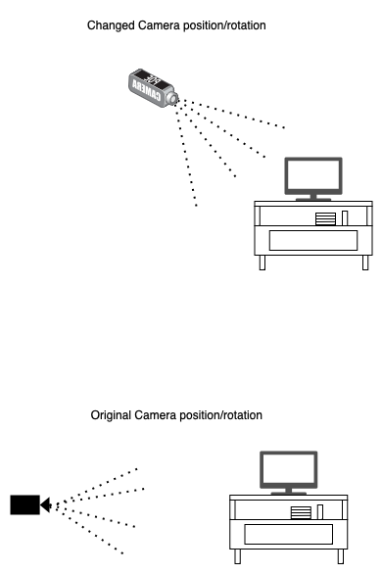

Camera without changes:  
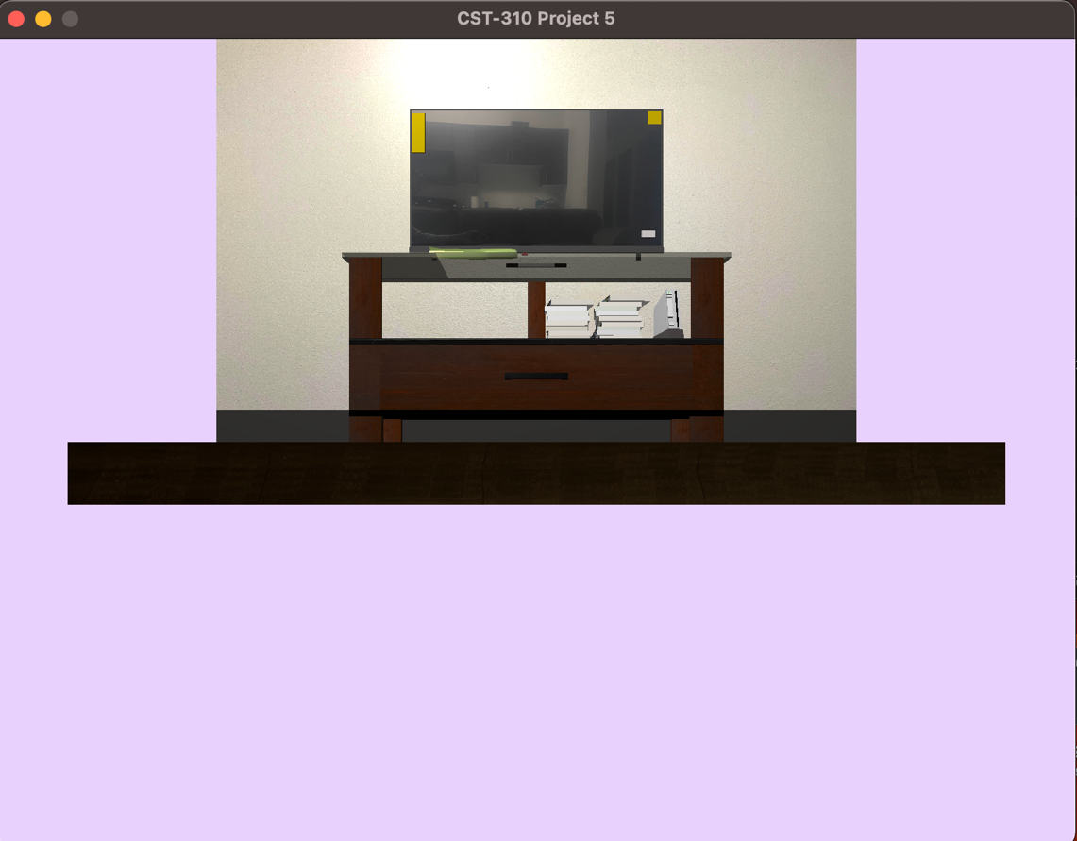

Camera with changes:

